JENTECH INTERNATIONAL offer many customize converting solutions for both for our converting customer’s requirements.
We have the ability to convert a wide range of material like foams, films, metal foils, papers & cloth based materials into your requirements either in roll formats, laminates or into die-cut shapes.
JENTECH INTERNATIONAL process capability includes:

- Coating - Widths up to 1300mm
- Rewind slitting - Widths down to 3mm
- Rotary or Flat Bed Die-cutting- Adhesive & Non-Adhesive parts
- UV Printing - Widths up to 250mm
- Material Lamination- Insulated foils down to 3mm
- Roll slitting - Up to 66mtrs length

FOAM DIE CUT KAPTON DIE CUT COPPER DIE CUT
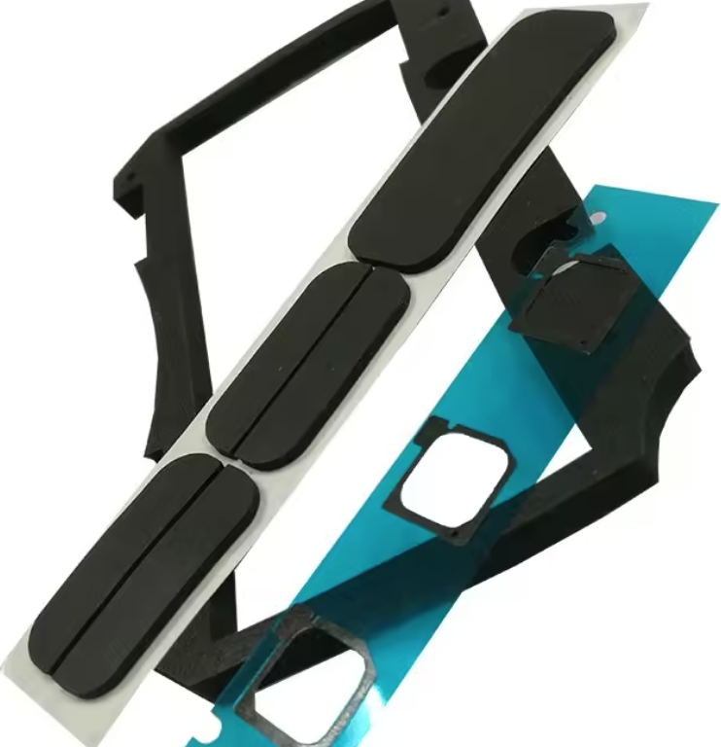
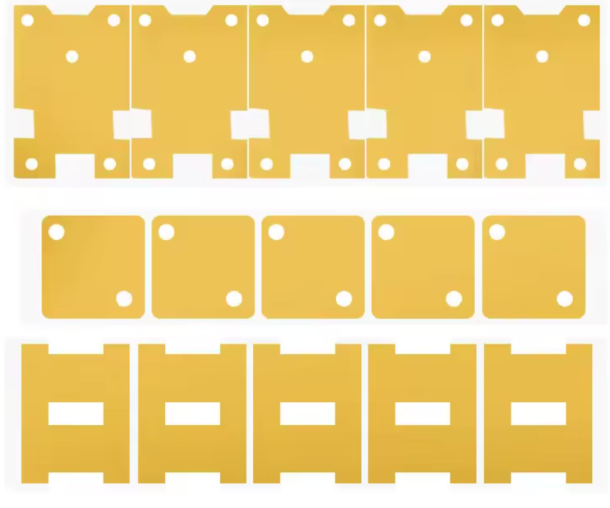
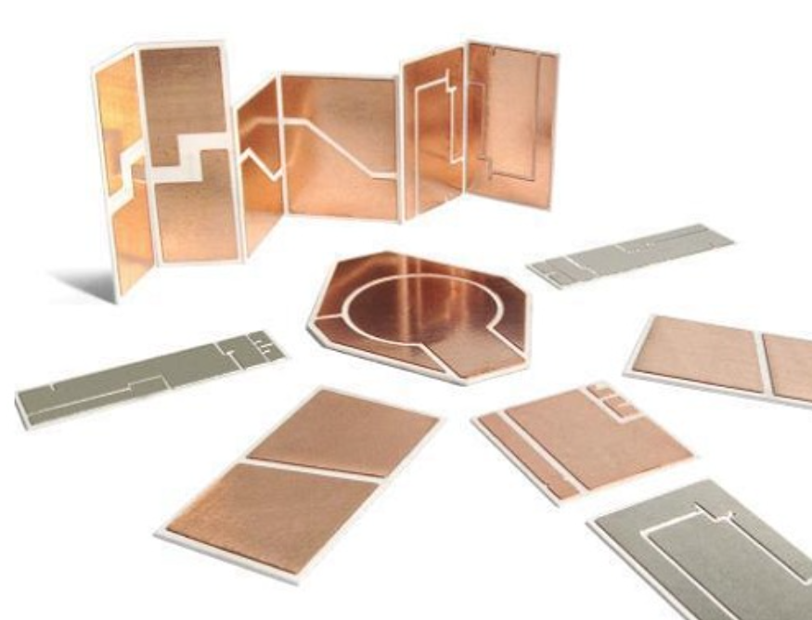

NOMEX DIE CUT


